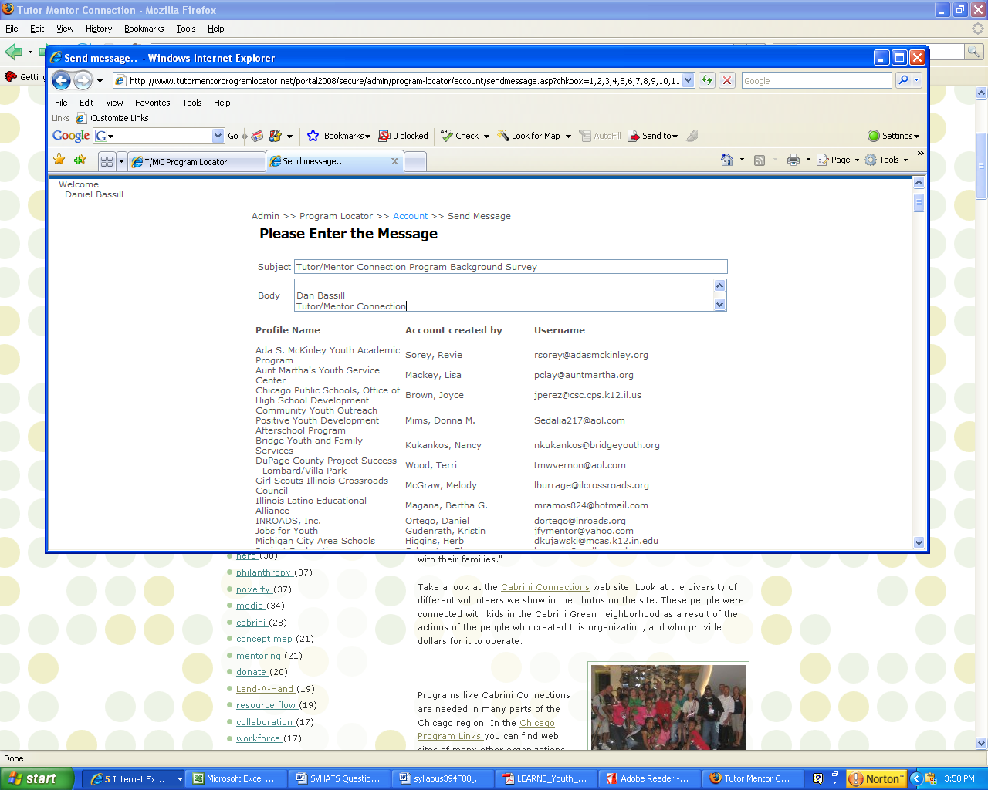

Send a message feature;

- needs to sort by “active programs” first, then be able to use the “send all” feature. When I selected only those who I wanted to receive email, the list still seems to be sending to everyone.

